

**The Social Acceptance of Wind Energy in Austria and the Czech Republic**

**Martin Schoenberg**

**Rostislav Moric**

Co-operating Universities



Financial support by



# Content

Content 2

Abstract 3

Paper 4

1 Motivation 4

2 Methodology 5

3 Results 6

3.1 Wind Energy in Austria 6

3.2 Wind Energy in the Czech Republic 8

History of using wind energy in the Czech Republic 8

State Energy Policy 9

State policy for saving energy and support of renewable energy sources 9

Energy act 10

Necessary condition of doing business 10

3.3 Survey 11

3.4 Results of Surveys: A Comparison of both Countries 14

4 Conclusion 15

5 Appendix 16

6 Literature 18

# Abstract

For years the worldwide installed capacity of wind power has been increasing. Nowadays the main focus is on the one hand on large-scale projects, such as off-shore parks and on the other hand on Europe’s leaders of wind energy production, like Spain and Germany. But also various other, small European countries do have a high potential for generating electricity by wind power plants. Beside economic criteria, social acceptance plays a decisive role regarding the realization of a power plant. In this paper the various attitudes and preferences of Austrians and Czechs regarding wind energy are elaborated.

The way we decided to find out the opinion of Austrians and Czechs about the usage of wind energy was an analysis of the status-quo in both countries and of various previous studies. In addition, a questionnaire among citizens of both countries was used to identify the reasons for the prevalence of certain attitudes and to figure out certain preferences that both countries have in common. The on-line questionnaire was mainly targeted at young people aged between 18 and 30 and focused on developing an opinion and perception.

The main result of this paper is that different attitudes of Austrians and Czechs towards renewable energies – in specific towards wind energy – do exist due to a  
different social and historical-political context. Since it is hard to derive specific recommendations regarding a so-called community acceptance of wind energy we suggest that further analysis have to be carried out on a regional and local level.

# Paper

## 1 Motivation

Wind power is seen as a clean and safe form of renewable energy. Many members of the European Union have been trying to increase the share of renewable energies, in especially by realizing huge on- and offshore wind parks. One might argue that just a large scale implementation is able to yield a profit. But due to technological improvements and diminished acquisition costs wind power has turned out to be a well-established technology even in regions with lower wind speeds, such as in Central Europe. It cannot be denied that wind energy can help to achieve a country’s climate target and to contribute to electricity production. It is obvious that for the realization of a project, apart from investment and further economic criteria, other, social features play an important part.

However, without the acceptance of residents, stakeholders or the local community no single (energy) project can be realized. Local resistance and debates about wind energy are nothing new and many studies reach the decision that the social acceptance is acting as a sort of constraining factor that is decisive whether a project can be realized successfully or not (Wüstenhagen/ Wolsink/ Bürer, 2007). In Austria far more wind power plants (as a total and number of new constructions per year) have been realized than in the Czech Republic - although both countries have a very similar wind energy potential (Dobesch/Kury, 1997) - leading to the question as to whether different attitudes and preferences of Austrians and Czechs regarding wind energy do exist or not. The main aim of the following paper is to present the current situation of the acceptance of wind energy in both countries and to derive recommendations that can be useful for the energy sector and for planners of actor-centered participation processes as well.

## 2 Methodology

In order to analyze and compare the preferences and attitudes of Austrians and Czechs towards wind energy lots of different studies were scrutinized. Furthermore a on-line questionnaire was set up. It was formulated in the way that various aspects of the well-known ‘*Triangle Model of Social Acceptance*’ that includes socio-political acceptance, community acceptance and market acceptance were integrated (Wüstenhagen/ Wolsink/ Bürer, 2007). The questionnaire with the main focus on ‘community acceptance’ was published via internet and was mainly targeted at young people aged between 18 and 30. To sum up, it was tried to detect possible predominant attitudes in one country, leading to a comparison of the results of the survey and of the literature research as well.

Since it is very hard to elaborate and measure qualitative features that are linked to social acceptance, we are aware of possible limitations of our work and conclusions. The chosen perspectives are mainly influenced by our bilateral point of view and our background, which includes systems sciences, environmental economics and business administration. Nevertheless we tried to develop an interdisciplinary approach by giving an overview of previous studies and by including new social, political and technical aspects.

## 3 Results

In the following subsections the situation of wind energy in Austria and the Czech Republic is scrutinized including an intra- and an inter-state analysis as well. The emphasis of the following parts lies on the elaboration of the various elements of the so-called community acceptance. *“[This]…refers to the acceptance of specific projects at the local level, including potentially affected populations, key local stakeholders and the local authorities. This is the area where social debate around renewable arises and develops, and the one that has attracted most of the social research traditionally carried out in the wind energy field.*” (Wind Energy the Facts I, 2012)

## 3.1 Wind Energy in Austria

In the last decade a high number of wind energy projects was realised in Austria. At the moment there are 656 wind driven power stations with a maximum capacity of 1.084 MW in Austria (IG Windkraft, 2012). In the last year (2011) 31 new plants with a capacity of 73 MW were erected (EWEA, 2012). As indicated above, the successful implementation of a wind energy project depends on various economic and social conditions. As early as in 1997 and 1999 this was taken into account by several Austrian studies (Forschungsforum I, 1999 and Forschungsforum II, 1997) that all suggested an actor–centered analytical approach to social processes for the analysis of the realization of wind power projects: “*The successful realisation of a wind power project depends, ..., above all on the interaction between the actors involved and on the decision process on a local level*” (Forschungsforum I, 1999). Further opinion surveys on wind power in Austria were carried out in the first decade of the new millennium. In 2003 the well-known Austrian Gallup Institute asked 1500 Austrians which means of electricity production they liked most and which energy sources should be promoted. Wind power received after hydro- and solar power the best scores (Wind Directions, 2003).

But who thinks that wind power stations in Austria get a similar high support and are distributed the same across the whole country is completely wrong: Most of the wind power stations are concentrated in the north-eastern parts of Austria. In general, two main interconnected reasons for this phenomenon can be distinguished.

Firstly, natural preconditions constitute the deciding factor for the planning and realization of wind power plants. Beside sea level and climatic factors, such as average wind speed, population and industry density play a decisive role. Shortly, the implementation of a wind energy project depends on differences of the landscape, such as geomorphological, and local climatic factors that both vary from region to region.

Secondly, attitudes and preferences of the local population (that can be linked to ecological criteria as well) influence and determine a successful implementation of a wind energy project. Examples show that the preferences of local governments decide whether a power station is going to be realized or not. In these cases the main arguments are not based on “efficacy and economy” but often refer to crowded landscapes, wildlife (birds and bats), turbine proximity to residences, health, safety, nuisance and annoyance (Lantz, 2011). Strong resistance can also be expected in the case that a power station is planned near or within a natural reserve (a case in point is the Naturpark Dobratsch near Villach) and/or various elements of social acceptance (identified by Lantz) are being affected: well-being (standard of living, quality of life, health, lights, noise and shadow flicker, valuation of ecosystems), policy and strategies (national framework incentive programs, spatial planning, local implementation policy), procedural design (regulatory requirements, fair and transparent processes, the role of public engagement, provisions for cultural history/local context), distributional justice (Ownership models, regional welfare, creation of win-win-situations) and implementation strategies (visualization, social marketing/communication, checklists/guidelines, practical application of scientific results) (Lantz, 2011).

To cut a long matter short, social acceptance has performed as a barrier to the erection of wind driven power stations in Austria presumably also because new impacts on a landscape have appeared. Their specific characteristics are a low energy density and a moving element that constitutes a new industrial infrastructure in rustic rural locations (Lantz, 2011).

In addition, it should be referred to the latest judiciaries in Austria that underline the role and importance of local actors because they intend the taking-down of erected wind driven power stations in the case that local residents were not involved and not being heard in the official procedure for the approval. Therefore, social acceptance in Austria is not only a precondition for the successful planning and erection of a wind driven power station but also necessary for an uninterrupted, operational activity.

## 3.2 Wind Energy in the Czech Republic

The electric energy is very important part of human life from different point of view. That’s the reason why our society has higher and higher demand on energy, not to say on resources of electric energy. Nowadays the demand on energy is still covered by producing the electric energy from fossil sources.

On the other hand the electric energy’s share produced from renewable sources is being increased and also measures for decreasing the energy consumption are implemented. Here are many reasons why to decrease the energy consumption:

* decreasing of fossil reserves;
* pricy fossil fuels;
* the push to cut down production of emissions that harm the environment.

The principle of fossil fuels exhaustibility has a meaning just from physical, natural and geological point of view, not from economical.

The wind power plants used for producing the electric energy to electric grids are quite new technical field in the Czech Republic, but its importance is still growing. The similar development is in European Union and in the World as well. During last ten years there has been “boom” of building wind power plants not just in the Czech Republic. It’s necessary to say that this way of producing electric energy belongs to the most discussed.

### History of using wind energy in the Czech Republic

In the Czech Republic the first wind mill was built in 1277 in a garden of Strahov monastery in Prague. The widest development of wind mill’s building was reached in 40s the 19th century in Bohemia; in Moravia the development was slower. In the Czech Republic there can be historically evidenced 879 wind mill. The first wind mill power plant was built in Českomoravská vrchovina hills in the beginning of the 20th century. Generally it could be said that the Czech Republic can’t be account among countries with progressive attitude of producing electricity from the wind considering for example coastal countries (ČSVE, 2009).

The development of wind energy had two main phases in the Czech Republic. First phase proceeded in the years 1990 – 1995. Main reason of development was offer of cheap wind mill power plants that were produced in a town of Frýdek – Místek. During this phase there was built 25 wind mill power plants that has had installed capacity of 8 180 kW. After this first phase the progress was stopped. There could be named few main reasons – lack of fundamental legislation, wind mill power plants built in the Czech Republic hadn’t gone through field tests, they were largely faulty and there was lack of specialists in the field of wind energy. We have to add another reason that the wind mill power plants built in first phase were built in inappropriate places. But there was the most importantly reasons was the price of purchase price of electricity produced in wind mill power plants that was appraised 1,13 Kč/kWh that didn’t guarantee return on investment (ŠTĚKL, 2006).

Second phase of development wind energy have started in November 2001 when Czech Energy Regulatory Office appraised the price of electricity produced in wind mill power plant by price assessment. This price was settled to 3 Kč/kWh that appraising has had an influence on building new wind mill power plants and helped to huge built-up of power plants in 2004 (KUBÍN/KONEČNÁ, 2008).

*Development of wind energy in the Czech Republic 1990 – 2006*

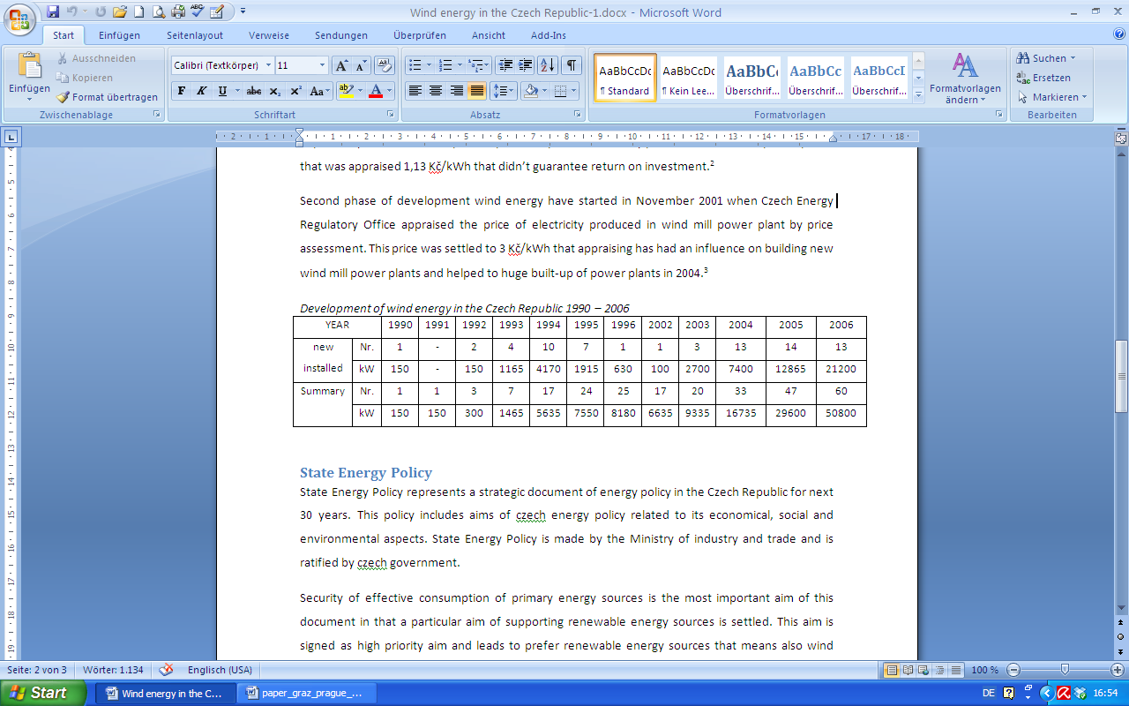

### State Energy Policy

State Energy Policy represents a strategic document of energy policy in the Czech Republic for next 30 years. This policy includes aims of Czech energy policy related to its economical, social and environmental aspects. State Energy Policy is made by the Ministry of industry and trade and is ratified by Czech government.

Security of effective consumption of primary energy sources is the most important aim of this document in that a particular aim of supporting renewable energy sources is settled. This aim is signed as high priority aim and leads to prefer renewable energy sources that means also wind energy sources.

### State policy for saving energy and support of renewable energy sources

(Zelená úsporám, 2009)

The Green Savings programme focuses on support for heating installations utilising renewable energy sources but also investment in energy savings in reconstructions and new buildings. The programme will support quality insulation of family houses and non-panel multiple-dwelling houses, the replacement of environment unfriendly heating for low-emission biomass-fired boilers and efficient heat pumps, installations of these sources in new low-energy buildings, as well as construction of new houses in the passive energy standard.

The Czech Republic has raised funds for this programme from the sale of emission credits under the Kyoto Protocol on greenhouse gas emissions. The overall anticipated programme allocation is up to 25 billion Czech crowns.

The Green Savings support has been set up so that the funds can be used throughout the period from the programme's launch until 31 December 2012. Applications for subsidies will be admitted until 30 June 2012 or until the programme funds are drawn down. A subsidy may be applied for before or after implementing the measure, but support for measures completed before the programme's launch cannot be granted. The support is granted for equipment installed in residential houses, not buildings intended for individual recreation or industrial buildings, even if the applicant has their permanent residence there.

### Energy act

The act nr. 458/2000 Sb., about the conditions of business and about execution of administration in energy sector and about changes other acts (below “energy act”) specifies the conditions of business, administration and nondiscriminatory regulation in energy sector.

### Necessary condition of doing business

The term of doing business in energy sector means producing electricity by energy act. Individuals and legal entity can run a business in energy sector only with state approval that represents a license granted by Czech Energy Regulatory Office and can by granted up to 25 years.

## 3.3 Survey

We try to find out what the Czechs and Austrians think about the renewable energy, especially about the wind energy, via online survey. Here are questions to our survey.

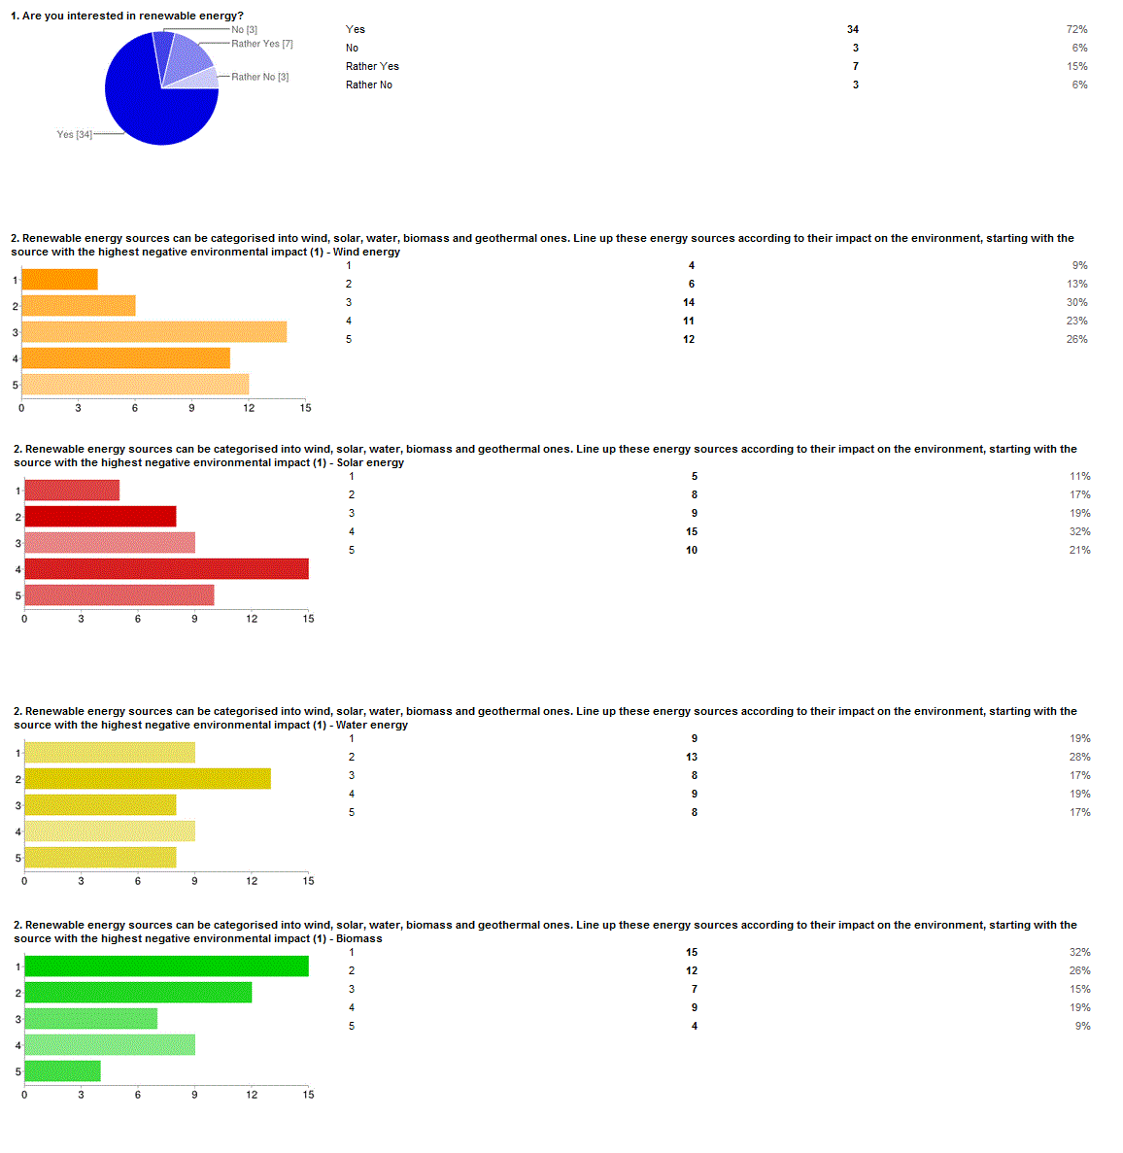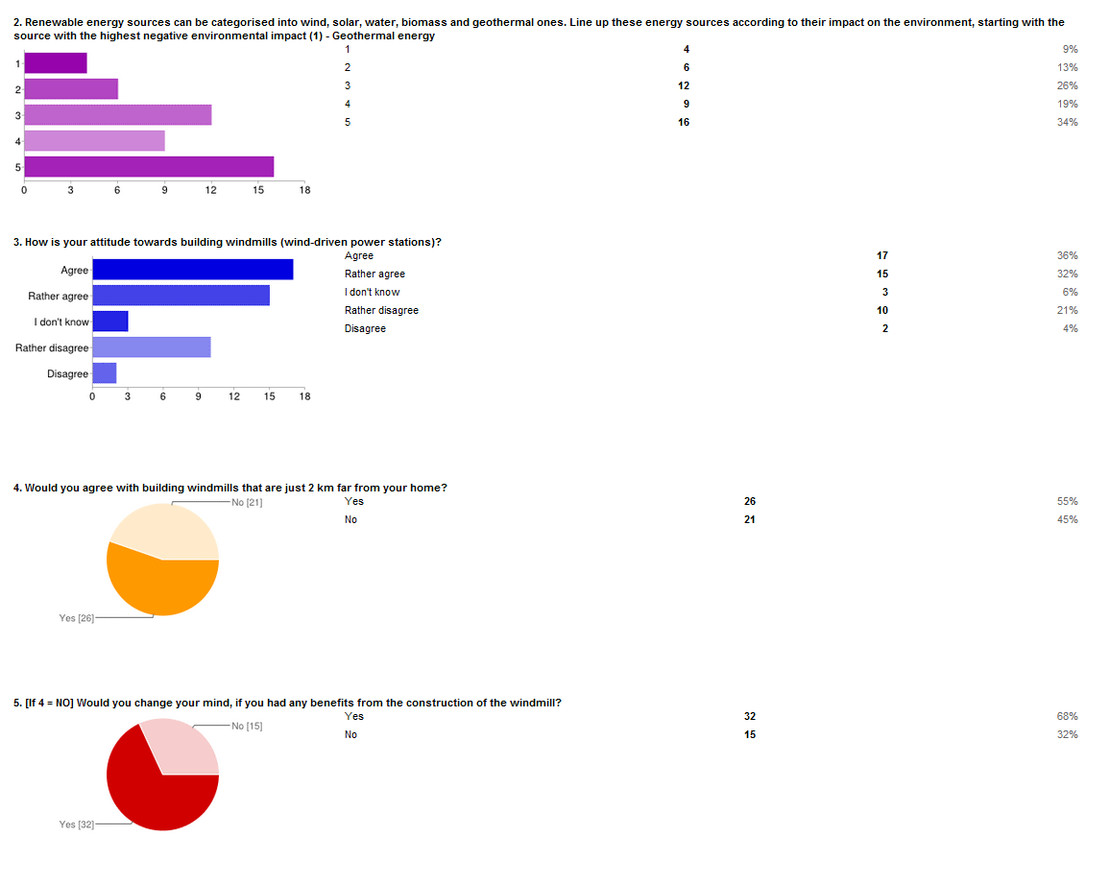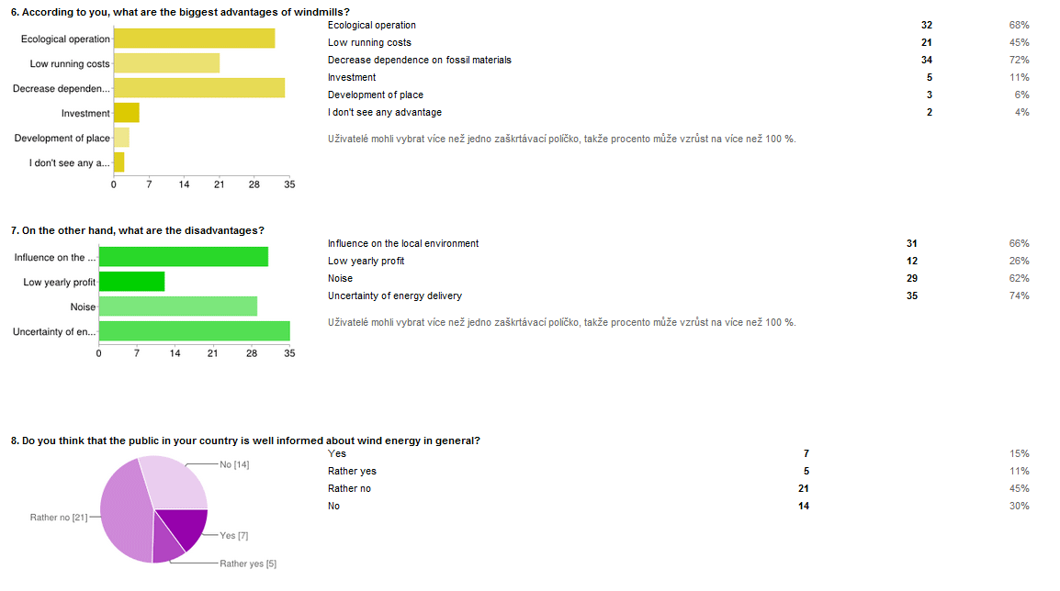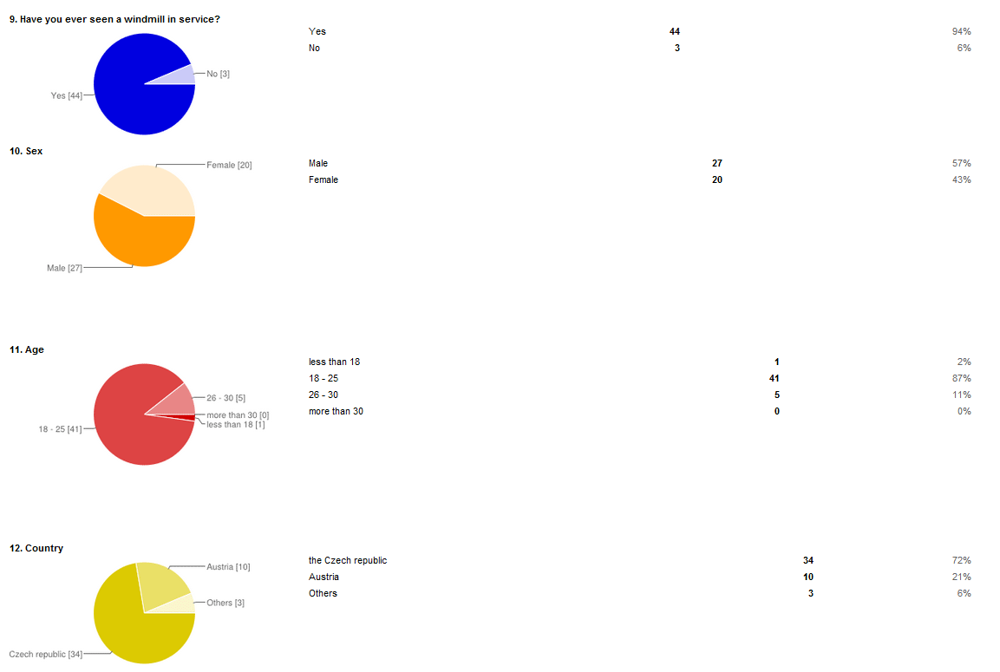

## 3.4 Results of Surveys: A Comparison of both Countries

As mentioned above, both countries seem to be very interested in and in favour of wind energy as a clean and safe form of alternative energy. But statistics show that the acceptance of renewable energies and especially of wind energy is not the same across Europe leading to the fact that some regions show a higher sensitivity to energy issues than others do: “*Respondents in EU15 countries tend to assign first priority to the promotion of renewable energy sources, ahead of ‘financial support for small businesses and households to make their energy consumption more efficient’ (42% against 31%) while the reverse applies in NMS12 countries, …”* (European Commission 2012, p.18-19)

The differences between Austria and the Czech Republic are that for the Czech republic (40%) “*financial support for households and SMEs is the first priority for EU energy policy*” (European Commission 2012, p.18-19) and that the Czechs have not “*mentioned wind energy among the three energy sources most likely to be used in their country 30 years from now*” (European Commission 2012, p.18-19).

Nevertheless, within all European countries the increase in the use of wind energy between 2007 and 2037 is expected to be around 36 per cent (Wind Energy the Facts II, 2012). The possible deviations between the dominating preferences in Austria and the Czech Republic – two cultures that can in general are considered to be very similar – might be caused by a different historical-political context. In various approaches the so-called ‘level of trust’ was investigated. This phenomenon could also play a decisive role within social processes that are part of the realization of wind power projects. In this case, a lower level of trust in post-Soviet civil societies could constitute an obstacle for the realization of new energy projects:

“*Getting all the pieces to fit together is made all the more difficult in new member states because of the lack of understanding and mistrust that exists among decision-makers, technical experts, and citizens. Various studies have demonstrated the low level of trust in post-Soviet civil societies,...* .” (Heinrich-Böll-Stiftung Brandenburg e.V., 2011)

## 4 Conclusion

For all the reasons we have mentioned above, we would say that the main result of this paper is that different attitudes of Austrians and Czechs towards renewable energies – in specific towards wind energy – do exist due to a different social and historical-political context.

Since it is hard to derive specific recommendations regarding a so-called community acceptance of wind energy we suggest that further analysis have to be carried out on a regional and local level.

According to our point of view social acceptance of wind energy in Central Europe is region and community-centered. In other words, preferences differ more between regions than between single nations. This can be supported by the fact that wind power stations are not distributed the same across one country or specific area although the same wind speed and various other similar (geomorphologic) preconditions are existent (Without assuming that the density of distribution of power stations is just a function of social acceptance).

To sum up, it is still obvious that it is easier to realize huge off-shore projects, but in future with the implementation of so-called ‘smart grids’ we cannot go past without including local residents. Hence, a high social acceptance, i.e. actor-centered models and processes, is and will be a precondition for the successful planning, erection and uninterrupted, operational activity of a wind driven power station.

## 5 Appendix

**Questionnaire**

1. Are you interested in renewable energy?

Yes /Rather Yes /Rather No /No

2. Renewable energy sources can be categorised into wind, solar, water, biomass and geothermal ones. Line up these energy sources according to their impact on the environment, starting with the source with the highest negative environmental impact

|  |  | 1 | 2 | 3 | 4 | 5 |  |
| --- | --- | --- | --- | --- | --- | --- | --- |
| Wind energy |  |  |  |  |  |  |  |
| Solar energy |  |  |  |  |  |  |  |
| Water energy |  |  |  |  |  |  |  |
| Biomass |  |  |  |  |  |  |  |
| Geothermal energy |  |  |  |  |  |  |  |

3. How is your attitude towards building windmills (wind-driven power stations)?

Agree /Rather Agree /I don’t know /Rather Disagree /Disagree

4. Would you agree with building windmills that are just 2 km far from your home? *

Yes /No

5. [If 4 = No] Would you change your mind, if you had any benefits from the construction of the windmill?

Yes /No

6. According to you, what are the biggest advantages of windmills? *

* Ecological operation



* Low running costs



* Decrease dependence on fossil materials



* Investment



* Development of place



* I don't see any advantage



7. On the other hand, what are the disadvantages? *

* Influence on the local environment



* Low yearly profit



* Noise



* Uncertainty of energy delivery



8. Do you think that the public in your country is well informed about wind energy in general? *

Yes /Rather Yes /Rather No /No

9. Have you ever seen a windmill in service? *

Yes /No

10. Sex *

Male /Female

11. Age *

Less than 18/ 18-25 /26-30/ more than 30

12. Country *

Formularende

Austria/ The Czech Republic/ Other

## 6 Literature

* ČSVE (2009). *Česká společnost pro větrnou energii: Z historie využívání energie větru v českých zemích* [online]. Available from: http://www.csve.cz/clanky/detail/36 [Accessed 10 April 2012]
* Dobesch, H./Kury, G (1997). *Central* *European Wind Atlas*, Figure A.7
* European Commission (2008). *Attitudes of European citizens towards the environment*, Fieldwork: November – December 2007, Special Eurobarometer 295/ Wave 68.2 – TNS Opinion & Social
* European Commission (2012). *PUBLIC OPINION IN THE EUROPEAN UNION*, Fieldwork: November 2011, Standard Eurobarometer 76 / Autumn 2011– TNS Opinion & Social [online]. Available from: http://ec.europa.eu/public_opinion/archives/eb/eb76/eb76_eu20_en.pdf [Accessed 22 April 2012]
* EWEA (2009). *Wind Energy – The Facts, A guide to technology, economics, and future of wind power.* European Wind Energy Association.Social Acceptance of Wind Energy and Wind Farms, p.399 -407
* EWEA (2012). *Wind in power, 2011 European* statistics. European Wind Energy Association [online].Available from: http://www.ewea.org/fileadmin/ewea_documents/documents/publications/statistics/Stats_2011.pdf [Accessed 22 April 2012]
* Forschungsforum I (1999). *Social Acceptance of Wind Power in Austria, An Analysis of the Social Processes involved in the Installation of Wind Power Plants.* [online]. Available from: http://www.socialacceptance.ch/Files/150_akzeptanz_wind_%C3%B6sterreich_en.pdf[Accessed 13 April 2012]
* Forschungsforum II (1997). Wind Power in Austria - Analysis of strategies and problems [online]. Available from: http://www.nachhaltigwirtschaften.at/publikationen/forschungsforum/991/teil1.en.html [Accessed 13 April 2012]
* Heinrich-Böll-Stiftung Brandenburg e.V. (2011). *Participation in Urban Climate Protection. Answers of European Municipalities* [online].Available from: http://participation.blogsport.de/images/SustainableEnergyDevelopmentandSocialAcceptance.pdf[Accessed 13 April 2012]
* IEA Wind Task 28 (2010). *Social Acceptance of Wind Energy, State-of-the-Art Report*, Stefanie Huber, Robert Horbaty, ENCO AG, Switzerland
* IG Windkraft (2012). *Windenergie in Österreich* [online].Available from: http://igwindkraft.at/index.php?xmlval_ID_KEY[0]=1047 [Accessed 22 April 2012]
* KUBÍN, Jiří/KONEČNÁ, Eva (2008). *Obnovitelné zdroje elektrické energie a jejich využití v oblasti Libereckého kraje*, Liberec, Fakulta mechatroniky a mezioborových inženýrských studií 2008, 43 pages, ISBN 978-80-7372-308-8
* Lantz, Eric (2011). *Social Acceptance of Wind Energy Projects “Winning Hearts and Minds”*, Task 28 within IEA RD&D Wind, IEA Wind side event at EWEA 2011, March 16th 2011, NREL [online].Available from: http://www.ewec2011.info/fileadmin/ewec2011_files/documents/Workshops/IEAWind/IEAWIND_Side_Event_EWEA2011_Acceptance_Eric_Lantz.pdf[Accessed 13 April 2012]
* ŠTĚKL, Josef (2006). Větrná *energetika na území ČR a u sousedů, Alternativní energie č. 6*, 2006, p. 4 - 5
* Wind Directions (2003). *A summary of Opinion Surveys on Wind Power,* Wind focus, in: WIND DIRECTIONS, Bimonthly Magazine, September/October 2003, p. 16-33
* Wind Energy the Facts I (2012).*The Social Acceptance of Wind Energy and Wind Farms* [online]. Available from: <http://www.wind-energy-the-facts.org/en/environment/chapter-6-social-acceptance-of-wind-energy-and-wind-farms/> [Accessed 13 April 2012]
* Wind Energy the Facts II (2012).*Social Research on Wind Energy Onshore* [online]. Available from:http://www.wind-energy-the-facts.org/en/environment/chapter-6-social-acceptance-of-wind-energy-and-wind-farms/social-research-on-wind-energy-onshore.html[Accessed 13 April 2012]
* Wüstenhagen,Rolf/ Wolsink,Maarten/ Bürer, Mary Jean (2007). *Social acceptance of renewable energy innovation: An introduction to the concept, in Energy Policy,* Volume: 35, Issue: 5, Publisher: Elsevier, Pages: 2683-2691

Zelená úsporám (2009). *About The Green Savings programme* [online]. Available from: http://www.zelenausporam.cz/sekce/582/about-the-green-savings-programme/ [Accessed 21 April 2012]